FCI-Standard N° 117 / 16. 03. 2001 / GB

GERMAN LONG-HAIRED POINTING DOG
(Deutsch Langhaar)

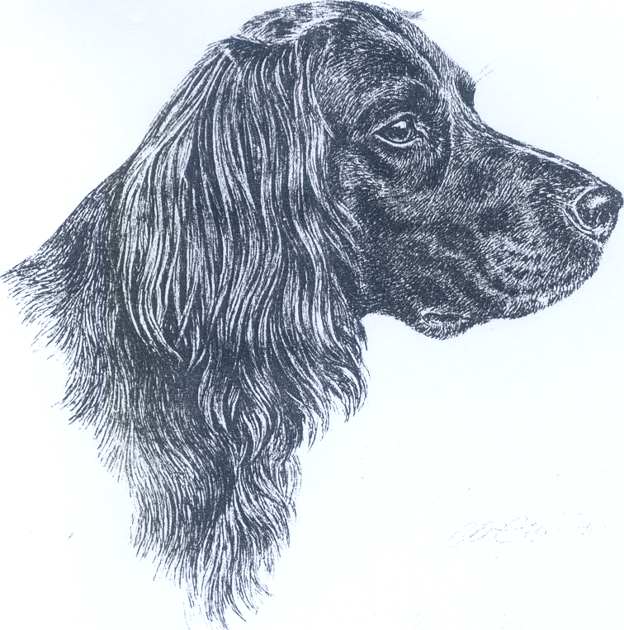
TRANSLATION : Mrs C. Seidler.

ORIGIN : Germany.

DATE OF PUBLICATION OF THE ORIGINAL VALID STANDARD : 25.10.2000.

UTILIZATION : Versatile working Gundog.

CLASSIFICATION F.C.I. : Group 7 Pointing Dogs.
Section 1.2 Continental pointing dogs, « Spaniel Type ».
With working trial.

BRIEF HISTORICAL SUMMARY : The German long-haired Pointing Dog combines the bloodlines of a bird-, hawk- and water dog as well as of Bracken (Scenthounds). He therefore has scope for great versatility. Pure breeding has been carried out since the year 1879 and main characteristics of the breed laid down. In the year 1897, Baron von Schorlemer set down the first standard for the German Long-haired and thus laid the foundation stone for today’s pure breeding.

GENERAL APPEARANCE : Strong; muscular; low set; flowing lines. Small dogs must have plenty of substance. Too massive and thereby clumsy dogs are not desired.

IMPORTANT PROPORTIONS : Muzzle and skull of equal length. Dog should not be overbuilt. Slightly higher at shoulder than rump.

BEHAVIOUR / TEMPERAMENT : Balanced, calm, controlled temperament, good natured, easily trained.

HEAD : Special value must be attached to the beautiful Long-haired head. Noble appearance, elongated.

CRANIAL REGION :
Skull : Slightly rounded.
Stop : Gently rising, not deep and sharp.

FACIAL REGION :
Noseleather : Brown, slightly lighter spots permitted.
Bridge of Nose : Lightly arched, not too slender.
Lips : Not overlapping too much.
Jaws/Teeth : Jaws not too fine. Well developed and complete (42 teeth) scissor bite i.e. upper incisors closely overlapping the lower incisors. Teeth formula : 3142
------- x 2 = 42
3143
Cheeks : Cheekbones not too strong.
Eyes : Colour : Brown, as dark as possible. Lids fitting close to eyeballs, without visible haw. Set neither too deep, nor protruding.
Leathers : Not set on too low, turned slightly forward.

NECK : Strong and noble. No dewlap. Getting harmoniously stronger towards the chest. Not too short.

BODY :
Back : Straight, firm, not too long.
Loins : Specially muscular.
Croup : Long, with moderate slope.
Chest : Forechest well developed, ribcage broad and deep, reaching at least to elbows.

TAIL : Carried not too steep. It should be carried horizontally, the last third being slightly turned up.

LIMBS

FOREQUARTERS :
General : In normal stance, bones of upper arm, forearm and of foot, seen from the front, should form an almost vertical line.
Shoulder : Close fitting. Seen from side, in repose, shoulder-blade and upper arm should form approximately a right angle.
Elbow : Close fitting.
Pastern joint : Slightly angulated.
Pastern : Not quite straight.

HINDQUARTERS :
General : Seen from behind, the hip bone, upper thigh, bones of lower thigh and of foot should form a vertical line.
Hock : Special value is attached to good angulation.
Dewclaws : Are to be removed at birth.

FEET : Pads coarse and strong.

GAIT / MOVEMENT : Ground covering movement with good drive from hindquarters.

SKIN : Close fitting to body, no wrinkles.

COAT

HAIR : The greatest importance is attached to correct coat, neither excessive growth nor too short hair. On back and sides of body : Hair 3 - 5 cm, close fitting. On underside of neck, on chest and belly, coat may be longer.
- Belly : Well coated.
- Leathers : Hair wavy and feathered.
- Tail : With good plume, coated to tip.
- Back of front legs : Feathered.
- Back of hind legs : Feathered, forming breeches.
- Below hock : Hair significantly shorter. Too much feathering is not desired. Dense short hair between toes.
- Head : Hair much shorter, but all the same, longer than on a short-haired German Pointing Dog. Topknot not desired.
- On body : Hair is sleek, firm, smooth or slightly wavy, close fitting. Dense with good undercoat.

COLOUR :
- Self coloured brown.
- Brown with white or speckled markings (specially on chest and feet).
- Dark roan (with large or smaller dark brown patches; brown head, possibly with white blaze, snip or star).
- Pale roan (with large or smaller pale brown patches; brown head with possibly white blaze, snip or star).
- Mottled (many small brown spots on white background; head brown, possibly with white blaze, snip or star).
- Brown and white, either pure brown and white or with very few small spots (large brown patches with saddle or blanket. Head brown, possibly with white blaze, snip or star).
- Occasionally fawn markings may occur as a very old throw-back to the Hounds.

SIZE AND WEIGHT :
Height at withers : Dogs : 60-70 cm, ideal height 63-66 cm.
Bitches : 58-66 cm, ideal height 60-63 cm.
Weight average : 30 kg.

FAULTS : Any departure from the foregoing points should be considered a fault and the seriousness with which the fault should be regarded should be in exact proportion to its degree and its effect upon the health and welfare of the dog.
- Eyes : Pale hawk-eye, slanting position of eyes.
- Ears : Not carried against the cheeks, leathery tips.
- Back : Hollow back, roach back.
- Chest : Barrel shaped or too narrow.
- Tail : Curled or hooked tail.
- Forequarters : Scapulo-humeral angle too open, pastern too straight.
- Hindquarters : Cowhocked, bow legged.
- Feet : Splayed feet, cat or hare feet.
- Texture of coat : Longer hair on beard; bushy eyebrows; curly coat.

ELIMINATING FAULTS :
- Aggresive or overly shy.
- General appearance : Dogs with insufficient bone and muscle.
- Head : Dogs with heads diverging from breed type.
- Eyes : Ectropion (lids turned outwards). Entropion (lids turned inwards). Also eyelids which have been corrected.

Any dog clearly showing physical or behavioural abnormalities shall be disqualified.

N.B. : Male animals should have two apparently normal testicles fully descended into the scrotum.

