FCI-Standard N° 98 / 23.10.2002 / GB

DEUTSCH DRAHTHAAR
(German Wirehaired Pointer)

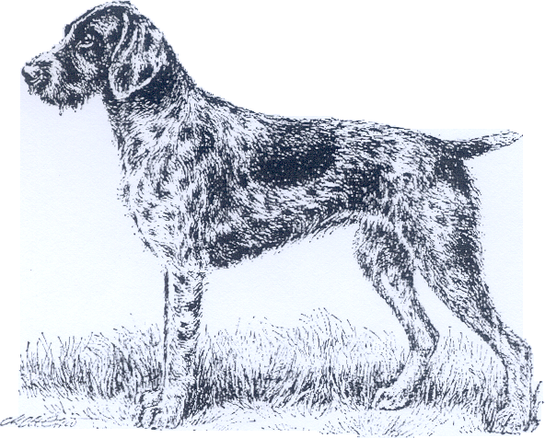

TRANSLATION: Elke Peper.

ORIGIN: Germany.

DATE OF PUBLICATION OF THE ORIGINAL VALID STANDARD: 25.10.2000.

UTILIZATION: According to his purpose of a versatile working gundog the German Wirehaired Pointer must possess all the dispositions asked for the breed. He must be usable for all the work in the field, in the woods and in water before and after the shot.

CLASSIFICATION F.C.I.: Group 7 Pointing Dogs.
Section 1.1 Continental Pointing
Dogs.
With working trial.

BRIEF HISTORICAL SUMMARY: The Deutsch Drahthaar is a rough coated pointing dog whose initial breeding started at the end of the 19th century (Griffon Korthals), and that has been systematically bred from the beginning of this century based on the ideas of „Hegewald“ (Sigismund Freiherr von Zedlitz and Neukirch) with the sealed aim of creating an assertive, efficient wirehaired German gundog. In accordance with the principle of „by working ability to type“ and with consequent regard to freedom of breeding, within a short time a gundog has been developed from the best of the rough coated types (Pudelpointer, Griffon Korthals, German Broken Coated Pointing Dog) and by using the German Shorthaired Pointer, that excels through his useful weatherproof coat and his versatility in all fields of practical hunting. Due to these characteristics, the Deutsch Drahthaar within a few decades has developed to become the most popular and well-tried among the large gundog breeds in Germany as well as in many countries of the world.

GENERAL APPEARANCE: A pointing dog of noble appearance, with harsh coat completely protecting the skin, with an attentive expression full of energy. The movement should be powerful, ground covering, flowing and harmonious.

IMPORTANT PROPORTIONS: The length of the body and the height at the withers should be as equal as possible. The length of the body may exceed the height at the withers by up to 3 cm.

BEHAVIOUR / TEMPERAMENT: Firm, self-controlled, well-balanced, without shyness of game, neither sensitive when shots are fired nor shy or aggressive.

HEAD: In proportion to the size and the sex of the dog. Lines of head slightly diverging.

CRANIAL REGION:
Skull: Flat, slightly rounded at the sides only, moderately broad, pronounced superciliary ridges.
Stop: Clearly visibly pronounced.

FACIAL REGION:
Nose: Strongly pigmented corresponding to the colour of the coat. Nostrils well opened.
Muzzle: Long, broad, strong, deep. Slight roman nose.
Lips: Thick, close-fitting, not overhanging. Well pigmented corresponding to the colour of the coat.
Jaws / teeth: Large teeth. Powerful jaws with a regular, complete scissor bite with the upper teeth closely overlapping the lower teeth and set square to the jaws. 42 teeth according to the dentition formula.
Eyes: As dark as possible, neither too deep-set nor protruding, with an alert, lively expression. Eyerims well pigmented and close-fitting.
Ears: Of medium size, set on high and wide, not twisted.

NECK: Of medium length, strongly muscled; slightly arched napeline, clean cut throat, no dewlap.

BODY:
Topline: Slightly sloping from the withers in a straight line.
Withers: Pronounced.
Back: Firm, well muscled.
Loins: Short, broad, muscular loin region.
Croup: Long and broad, slightly sloping and well muscled. Broad pelvis.
Chest: Broad and deep with well developed forechest, the breastbone reaching as far back as possible. Ribs well arched.
Underline and belly: Slight tuck-up towards the rear in an elegant curve.

TAIL: Following the topline, carried as horizontally as possible or slightly raised, but not steep. Neither too thick nor too thin. Docked for the hunting purposes. (In countries where docking is prohibited by law, the tail may be left natural. It should reach to the hocks and should be carried straight or slightly sabre-like.)

LIMBS:

FOREQUARTERS: Viewed from the front, straight and parallel, viewed from the side, legs set well under the body. The distance from the elbows to the ground to be approximately equal to the distance from the elbows to the withers.
Shoulders: Well laid-back, sloping shoulder blade, strongly muscled. Forming a good angle together with the upper arm.
Upper arm: As long as possible, with well developed, lean muscles.
Elbows: Close to the body, neither turning in nor out. Good angulation between upper arm and forearm.
Forearm: Lean, set perpendicular, strong bones.
Carpal joint: Strong.
Pasterns: Slightly sloping.
Front feet: Oval-round with well-knit toes and sufficiently thick, tough, robust and well-pigmented pads. They are set parallel, neither turning in nor out in stance or when moving.

HINDQUARTERS: Viewed from behind, straight and parallel. Well angulated at the stifles and the hocks. Strong bones.
Upper thigh: Long, broad, muscular, with good angulation between pelvis and upper thigh.
Stifle: Strong, with good angulation between upper and lower thigh.
Lower thigh: Long, muscular and sinewy.
Hocks: Short, perpendicular to the ground.
Hind feet: Oval-round with well-knit toes and sufficiently thick, tough, robust and well-pigmented pads. They are set parallel in stance and when moving, turning neither in nor out.

GAIT / MOVEMENT: Covering lots of ground, with good reach and drive, parallel coming and going; with upstanding posture.

SKIN: Tight, close-fitting, without folds.

COAT:

HAIR: Wirehaired harsh, flat lying and dense. Outer coat approximately 2 to 4 cm long; dense, waterresistant undercoat. The outlines of the body may not be obscured by longer coat. Through its harshness and density it should provide as good protection against weather and injuries as possible. The lower parts of the legs, as well as the lower region of the brisket and the belly, should be shorter but densely coated, the head and the ears to be shorter and at the same time denser but never softer coated. Pronounced eyebrows and a well developed not too long, as harsh as possible beard emphasise the determined expression.

COLOUR:
- Brown roan with or without patches.
- Black roan, with or without patches.
- Brown with or without white chest patch.
- Light roan.
No other colour is permitted.

SIZE: Height at withers: Dogs: 61 to 68 cm.
Bitches: 57 to 64 cm.

FAULTS: Any departure of the foregoing points must be considered a fault and the seriousness with which the fault should be regarded should be in exact proportion to its degree and its effect upon the health and welfare of the dog.

SEVERE FAULTS:
- Short or narrow or pointed muzzle.
- Weak dentition.
- Very loose eyelids.
- Swayback or roach back.
- Heavily overbuilt.
- Elbows heavily turning in or out.
- Bandy-legged, cow hocked or close behind, in stance as well as in movement.
- Pacing permanently when stepping or trotting, stiff or mincing gait.
- Sparce coat, lacking undercoat.

ELIMINATING FAULTS:
- Any kind of weak temperament, especially gun or game shyness, aggressiveness, nervousness; fear biter.
- Over- or undershot bite, wry mouth, missing teeth other than P1, the canines being set too narrow.
- Entropion, ectropion, differently coloured eyes.
- Innate kinky or stumpy tail.
- Faulty pigment.

Any dog clearly showing physical or behavioural abnormalities shall be disqualified.

N.B. Male animals must have two apparently normally developed testicles fully descended into the scrotum.

